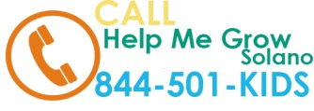

**One Call. That’s All.**

Resources for families in Solano County.

Have questions about your child’s development, behavior, or learning?

Call or go online to be connected to Solano County resources free of charge!







**1-844-501-KIDS (5437)**

Monday – Friday 9am – 5pm

Se Habla Español.

To go online visit: www.helpmegrowsolano.org



